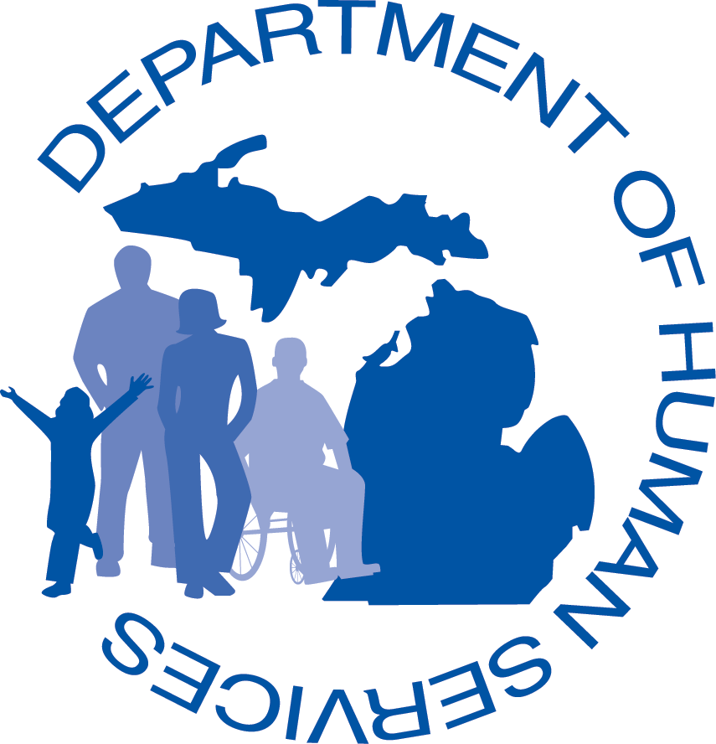

To Michigan Employer Partners June 20, 2011

The National Automated Clearing House Association (NACHA) manages the development, and administration, and governance of the ACH Network, which serves as a safe, secure, reliable network for direct consumer, business, and government payments. Utilized by all types of financial institutions, the ACH network is governed by the NACHA Operating Rules (Rules), a set of fair and equitable rules that guide risk management and create certainty for all participants.

NACHA requests comment on proposed amendments to the Rules to address six risk management-related topics and to provide additional flexibility for compliance with certain existing Rules. Of immediate concern is the proposed change that would revise the Rules to prohibit the inclusion of Social Security Numbers (SSNs) within ACH Entries unless such numbers are truncated.

This initiative to suppress SSNs in ACH payments would also include the SSNs contained within the child support addendum record. The MiSDU depends on the SSN to identify and correctly apply electronic child support payments. The Office of Child Support encourages our Employers to examine the implications such a proposal would have on your business and to utilize the comment period to voice any concerns.

NACHA requests feedback on whether any ACH participants have a legitimate need to transmit a full SSN within an ACH transaction without the suppression of the first five digits. If so, NACHA is interested in feedback on whether it is feasible to encrypt the SSN prior to incorporation into the Entry by the Originator with decryption only by the Receiver. NACHA has developed an ACH Participant Survey to petition feedback from users. The survey should be completed online at http://www.surveymonkey.com/s/YT657VT by Friday, June 24, 2011. Additional comments may be sent to Maribel Bondoc, Manager, Network Rules at mbondoc@nacha.org.

